The Inness
Queen Bed
The Hirsch
King Bed
The JHB
King Bed

The Gifford
Two Queen Beds
The Church
King Bed
The Cole
King Bed / Sofa Bed

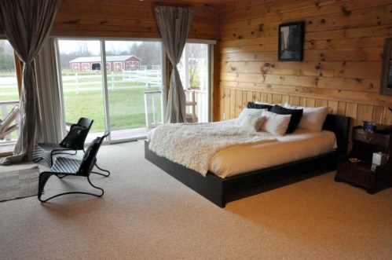
The Thomas Cole Suite- Named after artist Thomas Cole, Cole was the founder of the local Hudson River School of painters. This suite is on the bottom floor of the Dutch Barn Inn, and includes private bath with Jacuzzi, ground floor covered terrace, wood burning fireplace and a king bed as well as a sofa bed.
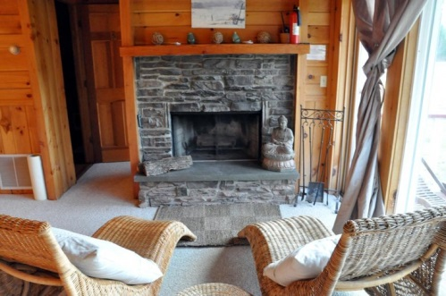
The Frederic Edwin Church Suite - The Church Suite at The Kaaterskill is named for Frederic Edwin Church, one of the Hudson River School painters and a founding member of the Metropolitan Museum of Art. This suite is on the bottom floor of The Dutch Barn Inn, and includes private bath with Jacuzzi, ground floor covered terrace, wood burning fireplace and a king bed.
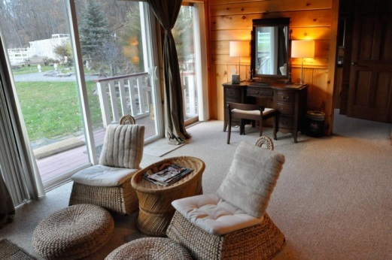
The Sanford Robinson Gifford Suite – Named after Hudson River School painter Sanford Robinson Gifford, this suite is on the bottom floor of The Dutch Barn Inn. It includes private bath with Jacuzzi, ground floor covered terrace, wood burning fireplace and two queen beds.
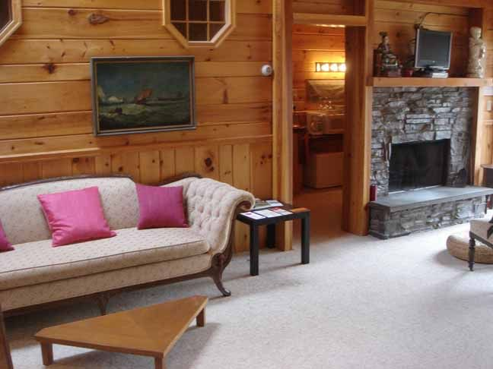
The George Inness Suite - Named for Hudson River School painter George Inness, this suite is located on the second floor of The Dutch Barn Inn, and includes private bath with Jacuzzi, covered terrace, wood burning fireplace and one queen bed. (Please note that this suite may be changed into a King in the next few months.)
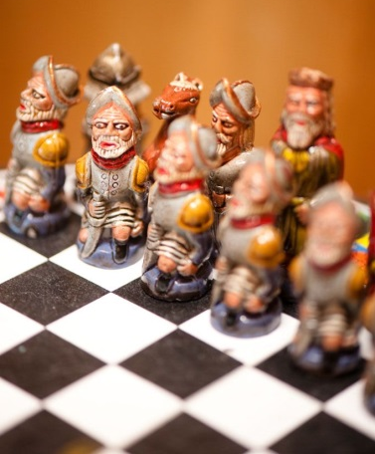
The Allen Hirsch Suite – Named after the owner / artist Allen Hirsch, this suite is typically used by the owners during off-wedding season as their private quarters. The suite is on the second floor of The Dutch Barn Inn, and includes private bath with Jacuzzi, covered terrace, wood burning fireplace and one king bed.
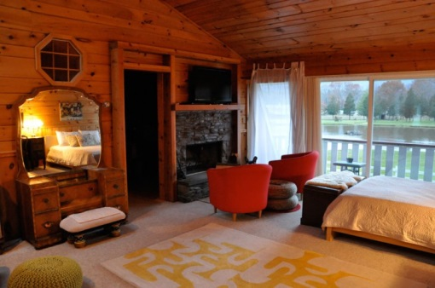
The Julie Hart Beers Suite – Often referred to as The JHB, the Julie Hart Beers suite was named after one of America’s first female landscape artists, very fond of The Hudson Valley and Hudson River itself, Julie Hart Beers. This suite is located on the second floor of The Dutch Barn Inn, and includes private bath with Jacuzzi, covered terrace, wood burning fireplace and one king bed.

